

NM-Logo-stacked-2090.png

**Contact Us**

TOLL-FREE: **888-933-1327**

TTY/TTD: **630-933-4833**

**www.NM.ORG/EAP**

PASSWORD: **PDC14**

TALKING WITH TEENAGERS ABOUT VIOLENCE

# PG: 7

GETTING A GOOD NIGHT’S SLEEP

# PG: 9

Stress and Your Body

# PG: 2

# FOR A FIT FAMILY

# PG: 4

**SUMMER  
ISSUE**

# 2019

**STRESS AND   
YOUR BODY**

**What is   
the most common cause   
of most headaches and muscle aches?   
The answer is tension and stress.**

Today, it's common knowledge that what happens mentally and emotionally has a significant effect on the physical, and vice versa—so what about *stress*? Physically, stress isn't always a bad thing. Stress hormones are what help people out in emergency situations, allowing their bodies to move into lifesaving action.   
Also, it's actually good for people to deal with some stress in order to build up a tolerance for stressful situations. The problem comes when people are on overload or have to handle too much stress too often. It's then that stress affects people in ways they might not always be aware of.

**Physical Impact of Stress**

Everyone is familiar with signs of stress such as nervousness, anxiety, and depression, as well as the other ways stressors can upset a person's state of mind. Here's a look at what stress can do to people's bodies:

* **Heart Disease**—Added up, daily stress can lead to heart attacks. Type A personalities have an extremely high risk of developing abnormal heart rhythms, and the normal stress of everyday life negatively affects people already prone to heart disease.
* **Strokes**—People who are highly stressed, and even moderately stressed on a regular basis, have a significantly increased risk of a fatal stroke.
* **High Blood Pressure**—Stress hormones cause an immediate rise in blood pressure. While this may not create problems for everyone, chronic stress and hypertension is a deadly combination.
* **Lowered Immunity**—Stress hormones compromise a body's immune system so that it is more susceptible to the flu, colds, and other infectious diseases.
* **Digestive Problems**—Stress has been proven to reduce the amount of beneficial bacteria in the digestive system, which can lead to indigestion, diarrhea, constipation, and other problems.
* **Headaches and Muscle Aches**—What is the most common cause of most headaches and muscle aches? The answer is tension and stress.
* **Changes in Sleep Patterns**—Overstressed people often suffer from insomnia, or feel the need or desire to sleep too much, which can be a sign of depression.

*continued on page 3*

**SUMMER 2019**

2



* **Sexual Dysfunction**—Any type of psychological or emotional stress can be the cause of temporary sexual dysfunction in both men and women.
* **Hormonal Imbalances**—During stressful times, the mind sends emergency messages that upset the body's natural hormonal balance.

In addition, there are many stress-induced behaviors that can cause physical harm, such as overeating or eating the wrong foods, alcohol and substance abuse, and smoking.

**Help your body beat stress: Exercise.**

* Whether you like it or not, the best weapon against stress is exercise. Regular exercise—it doesn't matter what it is as long as it's consistent—helps your body deal with stress for a number of reasons:
* Exercise releases hormones that are natural antidepressants and increase your tolerance to pain.
* Exercise stimulates nerves that help the brain's ability   
  to accurately sense emotions. A clear mind can steer clear of misinterpretation and miscommunication, which are high-level stressors.
* Exercise connects to hormones that control the stress response and improves a body's ability to tolerate stress and changes.
* Exercise gets your mind in shape by giving you a positive place to release frustrations and take a break from your worries; it also leaves you with more energy.
* Exercise can reduce negative thinking and improve your self-image—it changes the way you look and feel.
* Exercise improves cardiovascular health—your heart is a muscle and can be strengthened like any other.
* Exercising is a direct hit on stress-induced muscle aches and headaches and helps to normalize sleep patterns and hormonal imbalances.

**Eat right to fight stress.**

* Under stress, people physically need more vitamins and minerals, but the foods that have them aren't the ones they grab. Foods rich in fat and calories are what people crave when they're stressed or depressed, and these comfort foods actually work—they do make people feel and function better in the short term. However, they're killers in the long run. These are the kind of foods that, especially when eaten under stress, turn into fat around the middle.
* In stressful situations, try to eat foods high in vitamins and fiber: poultry, fish, beans and legumes, low-fat dairy products, whole grains and cereals, and fruits and vegetables. Foods in complex carbohydrates—pasta and potatoes—can help reduce stress because they're more slowly absorbed by the body. Don't skip meals. Getting too hungry will only make you reach for the wrong foods when your blood sugar's low. Avoid caffeine, alcohol, and stimulants in medicines and beverages.

**Calm your body and mind.**

Other ways to physically take control of stress include these:

* **Breathing Techniques**—Breathing slowly and deeply automatically relaxes the body.
* **Yoga**—Slow exercising such as yoga connects breath, movement, and body control.
* **Meditation**—Find a quiet place to be alone, wherever you are, and try to clear your mind.
* **Relaxation Techniques**—Learn how to really relax, physically and mentally.
* **Stretching**—Take time to stretch whenever you find yourself in a tense position.
* **Walking**—Walk around the building instead of taking a coffee break, or get up 15 minutes early and walk around the block before you leave for work.
* **Sleeping**—Make sure you get just a little more sleep than you think you need during times of high stress.

Workplace Options. (Revised 2018). *Stress and your body*. Raleigh, NC: Author.

*continued*

**STRESS AND   
YOUR BODY**

3

**SUMMER 2019**



*continued on page 5*

Being a parent often means dealing with a whole lot of *shoulds*: You wake up every day knowing that you *should* eat smart, exercise, and set a good example for your children. You know it's important for the family to make decisions and participate in activities together, and you're continually reminded that it's best to get the kids started on healthy habits as early as possible. However, sometimes your life gets the best of you, and all of your good intentions go out the window. Try the following suggestions on for size, and see how they can help your family fit overall wellness into your everyday lives.

**Get active with choices.**

* Involve everyone by sitting down to a brainstorming session. Try to come up with all of the possible activities available to your family.
* Find out whether anyone has a particular interest, and help everyone discover something active that's particularly suited to them.
* Take stock of what equipment you have lying around the house. An indoor basketball hoop or old croquet set that was abandoned by one child may be just right for another who's gotten older.
* Discuss what might work in the way of healthy snacks or adapting favorite meals.
* Make sure each family member feels included in the process as you make changes together.

For a   
Fit Family

**summer 2019**

4

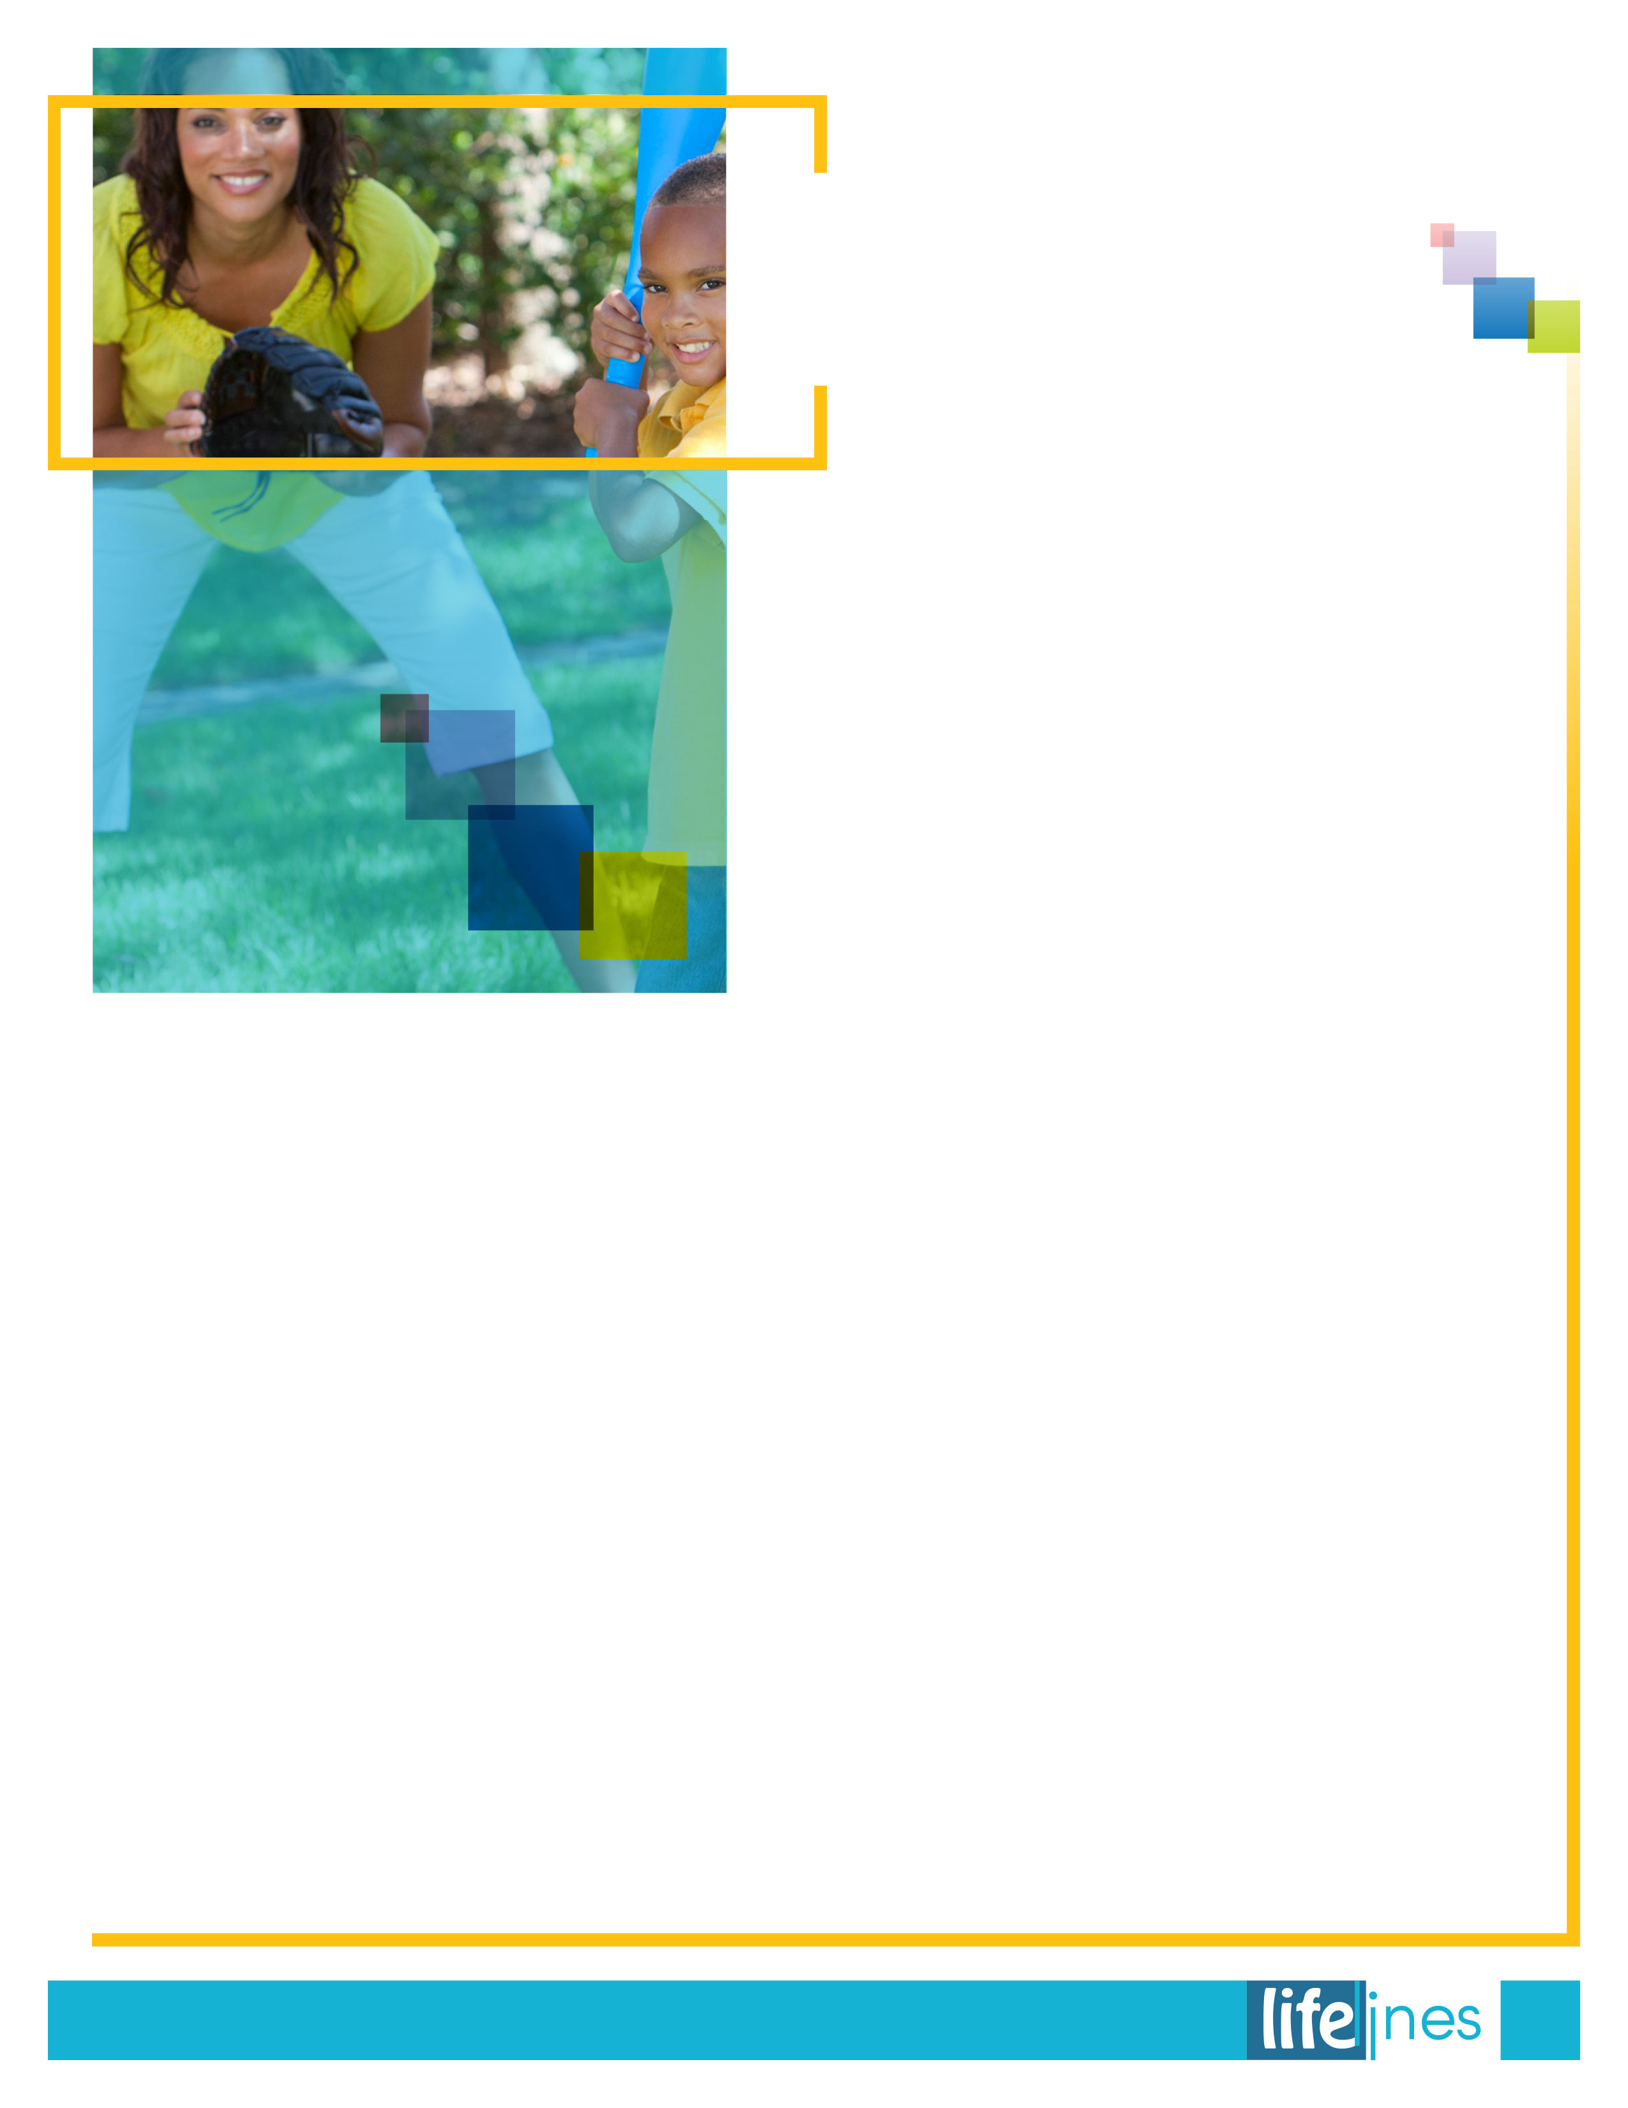

For a   
Fit Family

*continued on page 6*

**Schedule fun.**

* It's important that there's a regular time set aside for workouts, and that they're fun!
* Schedule at least a half hour most days a week and keep a variety of things happening: trips to the pool on Mondays; different physical activities in the backyard on Tuesdays; going for walks, skating, or riding bikes on Thursdays and Fridays. Then head to the park on the weekends.
* Keep in mind that regular activities need to be convenient. The easier it is to exercise, the greater the chance you'll go to the effort.
* Pick options that are free or within your budget. Physical fitness is an investment in wellness. It shouldn't put you under a financial strain.
* Take turns in selecting what you'll do, and start a fitness log for each family member.

**Find other families.**

* To keep yourself motivated, join with other families for swimming and water sports, nature hikes, skateboarding, miniature golf, kite flying, Frisbee tournaments, volleyball at the beach, or camping trips.
* Sign up for local softball games, a bowling league, or classes at a nearby gym, recreation center, or YMCA. The entire family can join a walking club.
* With neighbors, form your own flag football or basketball teams and set a weekly game time. Or organize an "Olympics" and get really creative about what kind of races and events you include.
* Have birthday parties—or any parties—at a roller skating or ice skating rink. As gifts, buy equipment or toys that promote activity: hula hoops, juggling supplies, or in-line skates (plus a helmet, knee pads, and elbow pads).

**Activities at Home**

* Set aside areas for active play, both inside and outside.
* Even if you don't have a big back yard, there's probably room for jumping rope, playing hopscotch, jumping on a pogo stick, or stilt-walking.
* Inside, build an obstacle course in the garage on a rainy day, or do indoor gymnastics. Get physical with a family game of charades. Have a dance contest. And set aside time to stretch, relax, and unwind.
* Limit TV to less than two hours a day, and take the TV set out of your child's room. Also place time limits on the computer and video games.
* Take the time to touch base with your child's teachers to see that your child is physically active at school, stays involved with games and intramural sports when appropriate, and is eating a healthy lunch.

**Kitchen Basics**

* Keep cut veggies, fruit, low-fat cheeses, nuts, and raisins around for easy snacking.
* Water should always be in the fridge. Small   
  bottles are more likely to be snatched up—find refillable containers.
* Try to pack snacks and lunches for outings and for school. There's no reason the kids can't help, or even be in charge.

*continued*

5

**summer 2019**

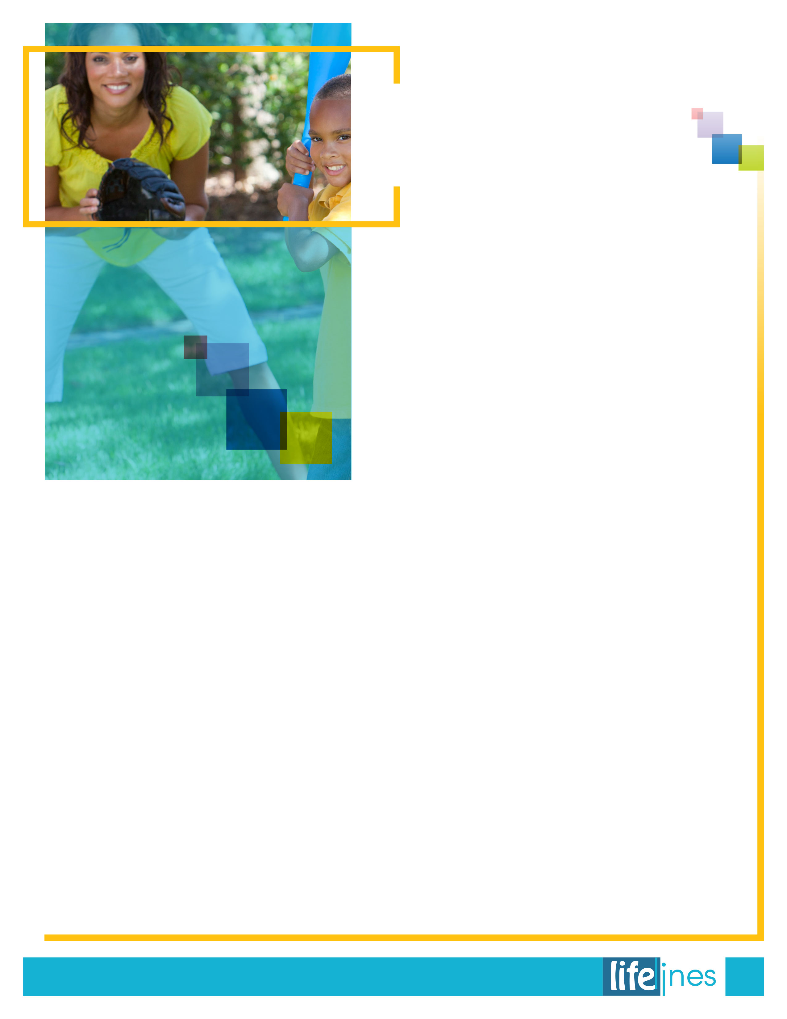

____________________________________________________  
Workplace Options. (Reviewed 2019). *For a fit family*.   
Raleigh, NC: Author.

* Involve the whole family in meal preparation. Toddlers are able to wash fruits and vegetables, mix ingredients, and set the table. School-age children can measure, use tools like an egg beater, cut with child-safe kitchen scissors, and follow recipes.
* Let everyone read food labels. Learn what to look for—fiber, added sugar, artificial ingredients, and fat content—and see if your taste buds change as you make healthier choices.
* Whenever possible, take the whole family grocery shopping and try new things. But don't give into demands for the latest candy, cookies, chips, and soft drinks.
* When it comes to bread and baked goods, whole grain is better!

**Make mealtime important.**

* Never skip breakfast. As hectic as a morning can get, make time for yogurt with fruit, whole-wheat toast and peanut butter, cereal with low-fat milk and fruit, or whole-grain frozen waffles.
* Get into the habit of serving fruit, salad, and vegetables with each meal. For adults as well as children, the goal is five to nine servings of fruits and veggies per day.
* Low-fat milk or dairy products should also be part of every meal.
* Eat meals together. In busy households it's sometimes difficult, but for children, a mealtime routine is just as important as a bedtime routine. Use family meals as an opportunity for catching up on everyone's individual activities.

**You're in charge of change.**

* Sure you watch your kids as a parent, but they're also watching you. Model good behavior when it comes to smoking, drinking, exercising, eating right, and finding a healthy way to relax—read a book, walk the dog, or listen to music instead of watching TV.
* Learn to say *no*. Putting restraints on outside activities and commitments which put too much pressure on the family is just as important as drawing boundaries for the kids.
* Pick your rewards. Instead of rewarding children with food or electronic game privileges, try rewarding them with your time and attention.
* Stay involved as you see and feel the changes in your family happening, and try not to leave anyone out. When you're together, remember to ask questions, tell stories, and turn to each of the kids for suggestions. If a family member visits, keep them in the loop and let them become part of your new and improved daily routine. It's more than likely you'll be doing them a favor.

*continued*

For a   
Fit Family

6

**summer 2019**



**Try to make them feel comfortable about talking to you, but don't force them to talk if they don't   
want to.**

* Talk or think about the event all the time
* Say the event didn't happen
* Use violence to get what they want
* Rebel at home or in school
* Stop being concerned about how they look
* Complain about being tired all the time
* Refuse to follow rules
* Spend more time away from home
* Not want to leave the house
* Get scared when thinking about the event
* Have nightmares
* Have difficulty paying attention in class or concentrating on work
* Do risky things (such as driving fast or jumping from high places)
* Want to seek revenge
* Change friends or dating relationships abruptly
* Become perpetrators or victims of violent dating relationships*
* Drink and use drugs*
* Start skipping school*
* Think about wanting to die or committing suicide*
* Break the law or destroy things*

*Take these actions seriously and seek professional help.

Teenagers may feel embarrassed to talk about what happened, but they won't want you to know that.Try to make them feel comfortable about talking to you, but don't force them to talk if they don't want to. Don't downplay their feelings by saying things like "Don't worry" or "Cheer up." Try not to make judgments or give advice. Instead, let them know you're there to help them find solutions.

**Teenagers are ages 12–18.**

You may not be the first person a teenager will turn to when he or she is upset. Teens are most likely to talk with their peers. Don't take it personally. Be mindful of your own reactions to the event and of the fact that adolescents need the support of calm caregivers. They may also fear that, as an adult, you will discount or underestimate the significance of their feelings. The best you can do is listen, remain open and available, and let them know you're there for them.

**If teenagers see or are hurt by violence, they may do the following:**

**summer 2019**

7

*continued on page 8*

Talking with Teenagers About Violence



___________________________________________________________  
U.S. Department of Justice (DOJ), Office of Justice Programs (OJP), Office of Juvenile Justice and Delinquency Prevention (OJJDP). (n.d.). Teenagers, ages 12–18. In *Healing the invisible wounds: Children's exposure to violence* (pp. 19–22). Retrieved April 16, 2019, from https://www.ojjdp.gov/

8

**summer 2019**

**Here are some things teenagers might do if you try to talk to them about violence:**

* Ignore you
* Change the subject ("I'm hungry")
* Blame others for the violence (for instance, by saying, "If you were nicer to him, he wouldn't hit you" or "You should have done what he said" or "Those kids were just asking for trouble")
* Run to his or her room and slam the door
* Say, "Don't worry," and try to cheer you up
* Try to hit you
* Listen quietly without saying anything
* Say, "Whatever"

Don't take any of these responses personally. Try some of the strategies listed below. Remember that healing takes time, and teens need you to be patient.

**Here are some ways you can help teenagers express what they're thinking and feeling:**

* Reach out to teens by asking, in private, "What's wrong?" Use conversation openings such as "You haven't seemed yourself lately," "You seem kind of down," or "Is something bothering you?"
* Encourage teens to talk about their feelings and tell their side of the story.
* Expect some difficult behavior, but don't let teens break the rules out of sympathy.
* Respond calmly to what teens have to say.
* Don't judge.
* Keep anniversary reactions in mind. For example, a teen may feel upset on the date the violence occurred, even years after the event.
* Show you understand by repeating in your own words what they said or felt. Let them know that the feelings are normal. For example, "It sounds like you really hated Dad when he was hitting you."
* Help them identify and label their feelings. For example, "I can understand why this made you angry."
* Praise their efforts to communicate their thoughts and feelings. For example, tell them, "I'm glad you are talking with me about this."
* Respond supportively when they tell you about the event. Don't disagree or try to lessen the intensity of their feelings.
* Encourage them to write about their thoughts and feelings in a journal.
* Encourage them to talk to people with whom they feel comfortable. They might choose to confide in close friends or a trusted teacher, coach, or counselor.

**Here are some things you can do to help teenagers feel safe and in control:**

* Be extra patient. They may be distracted and forget to do chores or turn in school assignments.
* Give straightforward explanations, whenever possible, for things that may worry them.
* Find out what's making them feel unsafe and help them make a safety plan. For example, you might suggest that they don't try to stop the violence themselves, and that they leave the place where the violence is happening and go somewhere safe.
* Support them to engage in comforting routines—listening to favorite music, playing sports, keeping a journal, looking at photographs. These can bring a sense of hope.
* Provide them with safe and fun physical activities to release the tension. Good choices of activities include those that they do well or enjoy.
* Enroll them in programs that teach conflict-resolution skills.
* Don't make commitments you can't honor. Don't say, "You'll be safe from now on." Instead you might say, "Let's make a plan to keep you as safe as possible."
* Suggest concrete things they can do. You might start by saying, "I'm sorry that this is happening to you. You're not alone. Let's take a look at your options."
* Help them think of positive ways to keep busy, such as playing sports, going out with friends, or making art or music.

*continued*

Talking with Teenagers About Violence



**Some people find that playing mental games makes them sleepy.**

**Getting a   
Good Night’s Sleep**

____________________________________________  
U.S. National Institutes of Health National Institute on Aging. (Updated 2015, December 22). *A good night's sleep*. Retrieved February 22, 2016, from http://www.nia.nih.gov

9

**summer 2019**

**Getting a Good Night's Sleep**

Being older doesn't mean you have to feel tired all the time. There are many things you can do to help you get a good night's sleep. Here are some ideas:

* Follow a regular sleep schedule. Go to sleep and get up at the same time each day, even on weekends. Try to avoid napping in the late afternoon or evening, as it may keep you awake at night.
* Develop a bedtime routine. Take time to relax before bedtime each night. Some people watch television, read a book, listen to soothing music, or soak in a warm bath.
* Keep your bedroom dark, not too hot or too cold, and as quiet as possible.
* Have a comfortable mattress, a pillow you like, and enough blankets for the season.
* Exercise at regular times each day, but not within 3 hours of your bedtime.
* Make an effort to get outside in the sunlight each day.
* Be careful about when and how much you eat. Large meals close to bedtime may keep you awake, but a light snack in the evening can help you get a good night's sleep.
* Stay away from caffeine late in the day. Caffeine found in coffee, tea, soda, and hot chocolate can keep you awake.
* Drink fewer beverages in the evening. Waking up to go to the bathroom and turning on a bright light break up your sleep.
* Remember that alcohol won't help you sleep. Even small amounts make it harder to stay asleep.
* Use your bedroom only for sleeping. After turning off the light, give yourself about 20 minutes to fall asleep. If you're still awake and not drowsy, get out of bed. When you feel sleepy, go back to bed.

**Safe Sleeping**

Try to set up a safe and restful place to sleep. Make sure you have smoke alarms on each floor of your house or apartment and lock the outside doors before going to bed. Other ideas for a safe night's sleep are

* Keep a telephone with emergency phone numbers by your bed.
* Have a good lamp within reach that turns on easily.
* Put a glass of water next to the bed in case you wake up thirsty.
* Use nightlights in the bathroom and hall.
* Don't smoke, especially in bed.
* Remove area rugs so you won't trip if you get out of bed in the middle of the night.
* Don't fall asleep with a heating pad on, as it may burn you.

**Sweet Dreams**

There are some tricks to help you fall asleep. You don't really have to count sheep, but you could try counting slowly to 100. Some people find that playing mental games makes them sleepy. For example, tell yourself its 5 minutes before you have to get up, and you're just trying to get a few extra winks. Other people find that relaxing their body puts them to sleep. You might start by telling yourself that your toes feel light as feathers and then work your way up the rest of the body saying the same words. You may drift off to sleep before getting to the top of your head.

If you feel tired and unable to do your activities for more than 2 or 3 weeks, you may have a sleep problem. Talk to your doctor about changes you can make to get a better night's sleep.